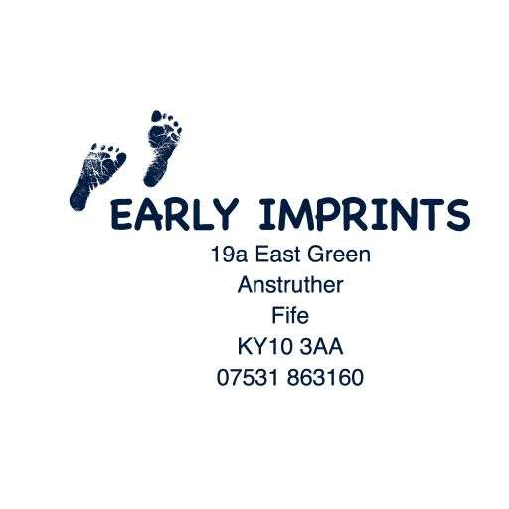
INTEGRATING EARLY IMPRINTS

APPLICATION FOR PROCESS WORKSHOP
1-5 December
Anstruther, Scotland
Dr. Charisse Basquin
Co-facilitated with Dr. David Bate, Practitioner-in-training

Name: Date:

Address:
Email:
Phone:

I am applying to the process workshop, Integrating Early Imprints, and I agree to the following conditions:

-to abstain from alcohol at least 48 hours prior to and during the workshop, including evenings
-to abstain from recreational and spiritual drug/medicine use a minimum of one week prior to and during the workshop, including the evenings
-to commit to staying for the duration of the workshop
-to keep evenings free of commitments because we do not know when each day will complete.

Please accept my application with a non-refundable deposit of £150
Fee £750 if paid before 20 Oct 2026 or £850 if paid after 20 October 2026.

CANCELLATION POLICY:
*If you cancel less than 6 weeks prior to the workshop you will be responsible for full payment of the workshop. However, if we are able to fill your place, you will only be responsible for £75.00. A waitlist will be created as soon as needed.

After I receive your application (e-mail please) and deposit, you will receive an email with a questionnaire about your birth and family history. I ask that the questionnaire be returned to me no later than 5 weeks prior to the workshop. That gives me enough time to prepare to support you and your intention for yourself.

Please Note: Full acceptance into this workshop is determined after I have received your completed questionnaire. This way, I can assess if this type of work appears appropriate for you and can support the intentions you have for yourself. If I believe this type of work is not supportive of you, I will refund your payment in full.

______________________________________
e-Signature

Banking details: Please let me know by email if you have made a payment.

Bank: Royal Bank of Scotland
Name of account: Charisse Basquin
IBAN: GB70RBOS83152100204806
BIC: RBOSGB2L
Sort code: 83 1521
Account number: 00204806

Sincerely,
Dr. Charisse Basquin

